**Project Design Phase-II**

**Technology Stack (Architecture & Stack)**

|  |  |
| --- | --- |
| Date | 27 June 2025 |
| Team ID | LTVIP2025TMID49412 |
| Project Name | Measuring the pulse of prosperity |
| Maximum Marks | 4 Marks |

**Technical Architecture:**

The Deliverable shall include the architectural diagram as below and the information as per the table1 & table 2

**Example: Order processing during pandemics for offline mode**

**Reference:** [**https://developer.ibm.com/patterns/ai-powered-backend-system-for-order-processing-during-pandemics/**](https://developer.ibm.com/patterns/ai-powered-backend-system-for-order-processing-during-pandemics/)

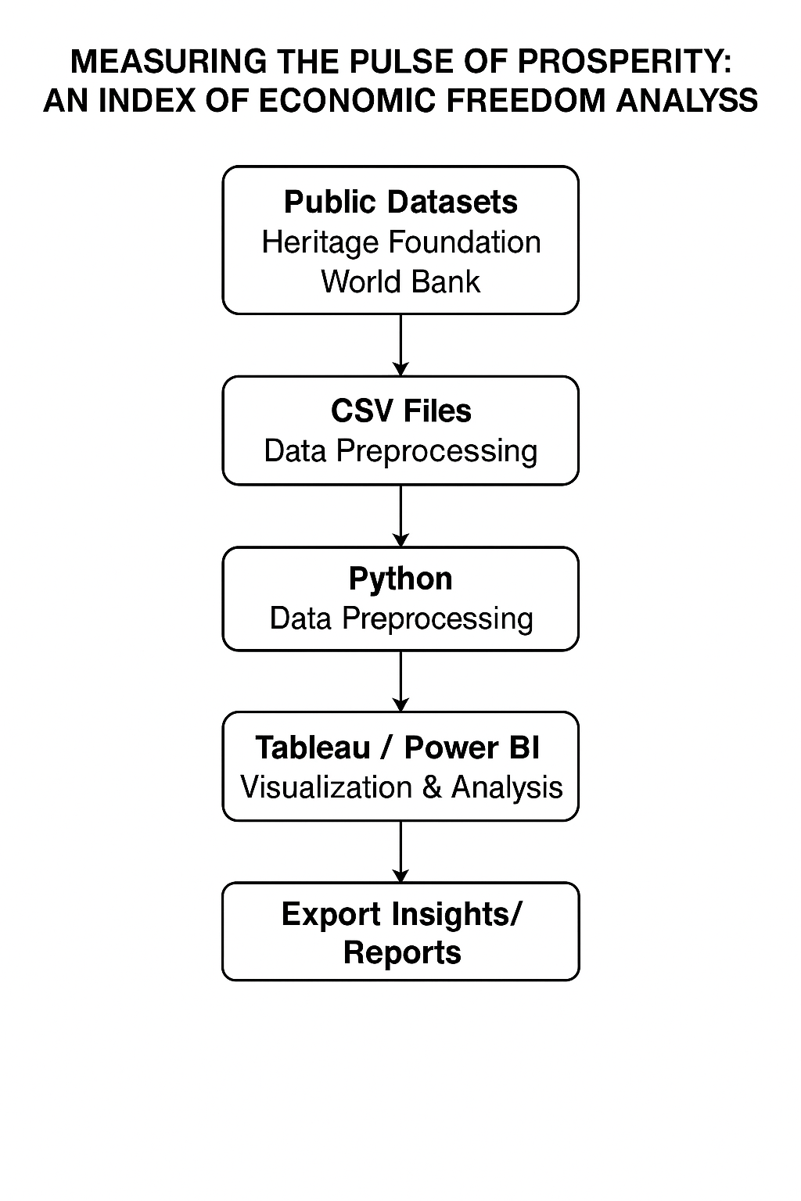

**Table-1 : Components & Technologies:**

|  |  |  |  |
| --- | --- | --- | --- |
| **S.No** | **Component** | **Description** | **Technology** |
| **1.** | **User Interface** | **How users interact with the system** | **Tableau Public / Power BI Web Dashboards** |
| **2.** | **Application Logic-1** | **Data preprocessing pipeline** | **Python (pandas, numpy)** |
| **3.** | **Application Logic-2** | **Correlation and statistical logic** | **Python (SciPy, statsmodels)** |
| **4.** | **Dashboard/Story Logic** | **Visualization & interactive logic** | **Tableau Filters, Parameters, Actions / Power BI DAX** |
| **5.** | **Data Source** | **Source of structured data** | **CSV datasets from Heritage Foundation, World Bank** |
| **6.** | **File Storage** | **Hosted data platform (if any)** | **Google Drive / GitHub for dataset hosting** |

**Table-2: Application Characteristics:**

|  |  |  |  |
| --- | --- | --- | --- |
| **S.No** | **Characteristics** | **Description** | **Technology** |
| **1.** | **Open-Source Frameworks** | **Frameworks for analytics and visualization** | **Python, Tableau Public, Power BI** |
| **2.** | **Security Implementations** | **Basic file access control, secure sharing of data and dashboards** | **Google Drive Permissions, Power BI Access** |
| **3.** | **Scalable Architecture** | **Cloud dashboards enable scalable sharing and embedding** | **Tableau Public / Power BI Cloud** |
| **4.** | **Availability** | **Dashboards can be published and available 24/7** | **Tableau Public / Power BI Service** |
| **5** | **Performance** | **Optimized data queries, dashboard filters, fast rendering visualizations** | **Tableau Public / Power BI Service** |

**References:**

[**https://c4model.com/**](https://c4model.com/)[**https://developer.ibm.com/patterns/online-order-processing-system-during-pandemic/**](https://developer.ibm.com/patterns/online-order-processing-system-during-pandemic/)[**https://www.ibm.com/cloud/architecture**](https://www.ibm.com/cloud/architecture)[**https://aws.amazon.com/architecture**](https://aws.amazon.com/architecture)[**https://medium.com/the-internal-startup/how-to-draw-useful-technical-architecture-diagrams-2d20c9fda90d**](https://medium.com/the-internal-startup/how-to-draw-useful-technical-architecture-diagrams-2d20c9fda90d)